**Lab 8 Submission**

**Question 1**

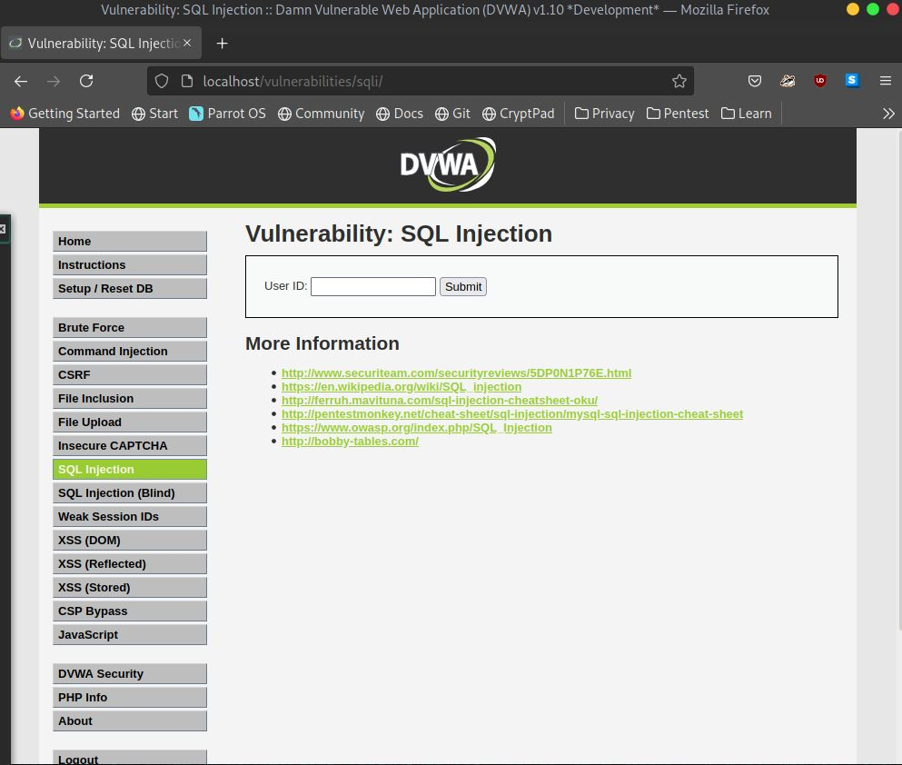

DVWA Main Site for input

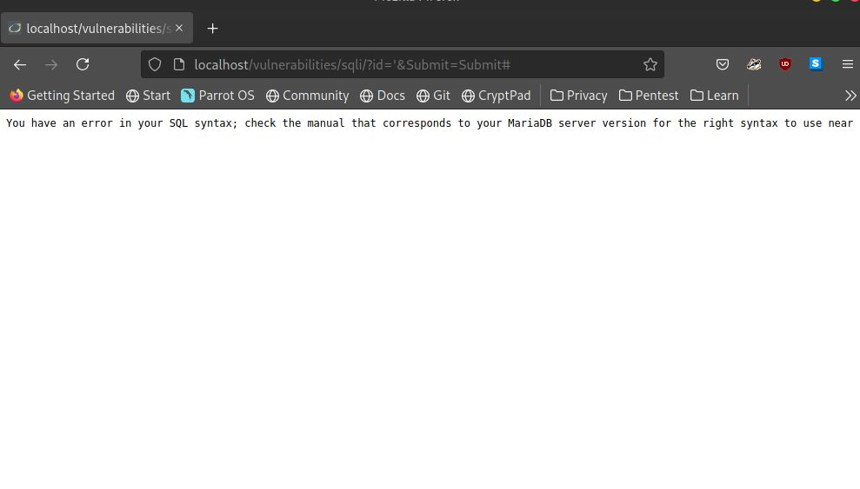

Check for Error

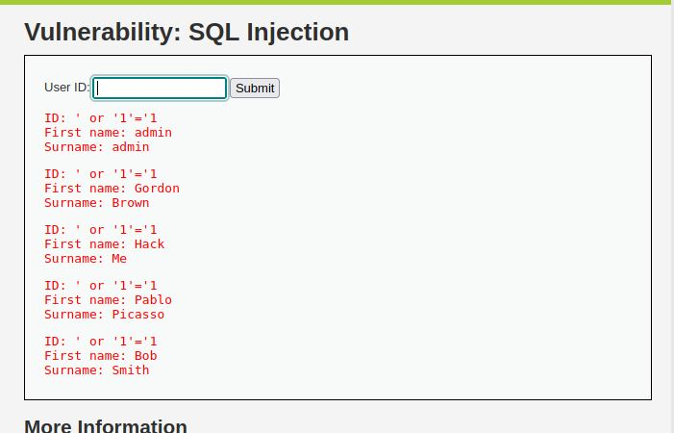

Injected 1=1 for all rows in the current table

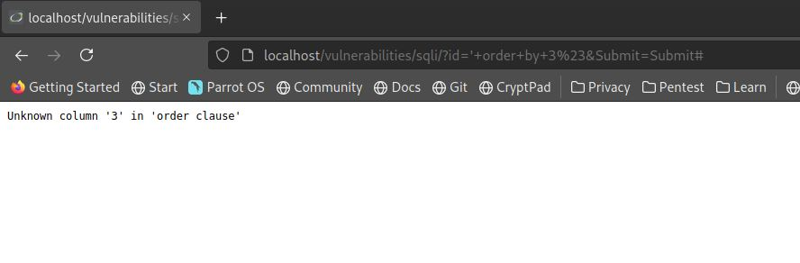

Order by 3. 3 columns are not there

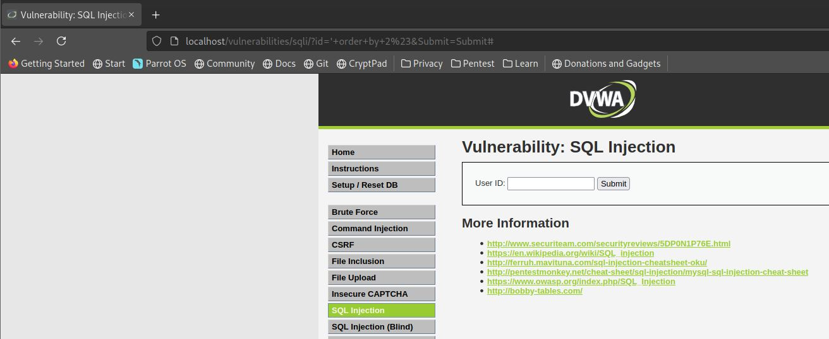

Order by 2 Columns. Max 2 Columns

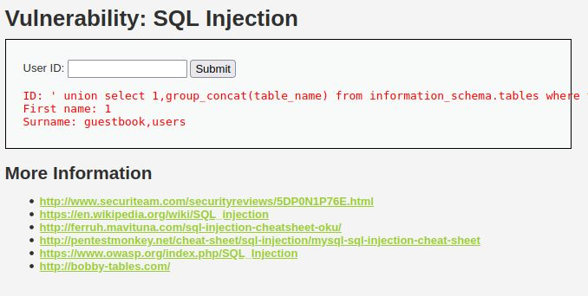

List Tables

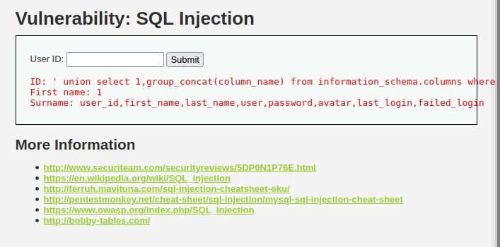

Columns of Table “users”

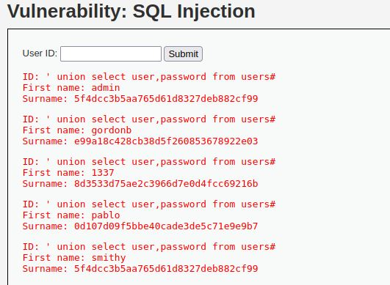

List usernames and passwords

**Question 2**

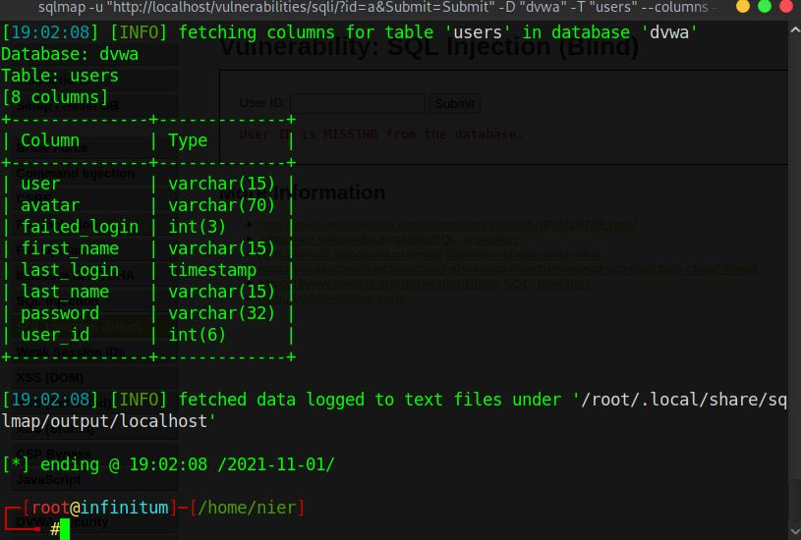

Columns of Users table by sqlmap

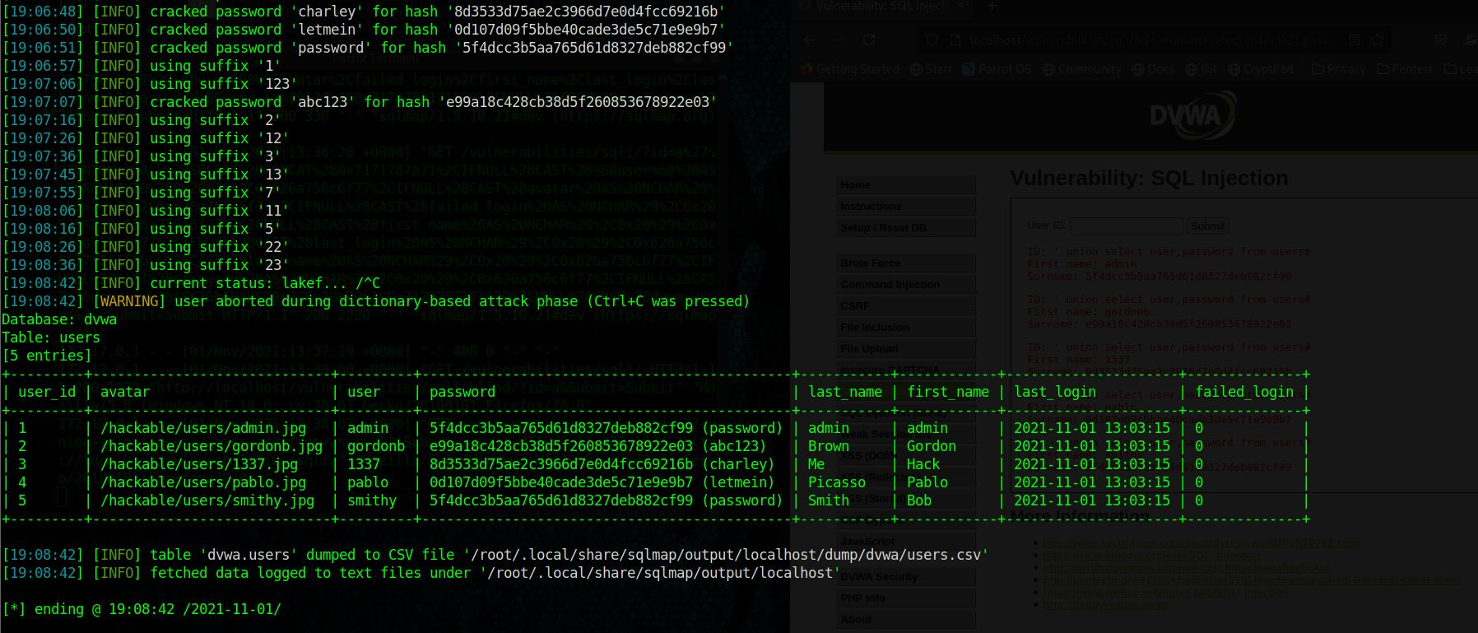

Cracked Hashes with dump of table “users”